**ODD OR EVEN – 8085 MICROPROCESSOR**

**AIM:**

To write an assembly language program to find the number is odd or even using 8085 Microprocessor in GNUSim8085

**SOFTWARE USED:-**

GNUSim8085

**ALGORITHM:-**

1. **I**nitialize the number in the accumulator
2. Perform the AND operation with accumulator by 01
3. If the result is ‘0’, it means it is even number
4. If the result is non zero, it means the given number is odd
5. Stores the out put in the register
6. End the program

**Program:-**

LDA 8100H ; Load the number from memory

ANI 01H ; AND with 01H to check LSB

JZ EVEN ; If result is 0, number is even

MVI A, 01H ; Set A = 01H (Odd flag)

JMP STORE

EVEN: MVI A, 00H ; Set A = 00H (Even flag)

STORE: STA 8200H ; Store the result at 8200H

HLT

**OUTPUT :**

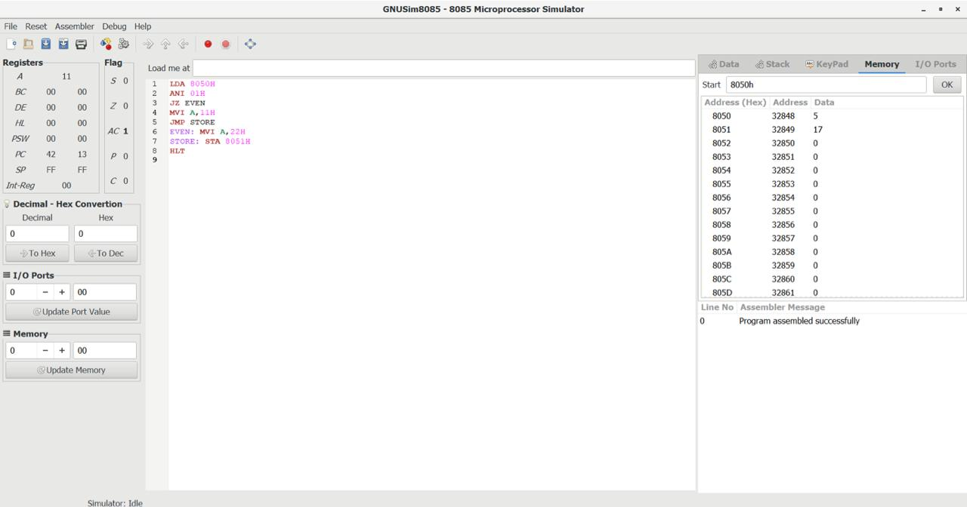

**RESULT:-**

Thus the assembly Language Program to find the ODD OR EVEN is performed using 2050H Microprocessor in GNUSim8085